1. Download and installation “IAR system”



1. Download Smartto source code <https://github.com/Geeetech3D/Smartto-IAR>,
2. Find the ‘GTM32.eww‘ file in the ‘Project’ folder and double click

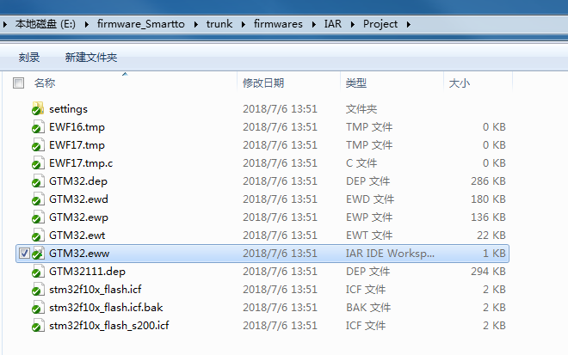

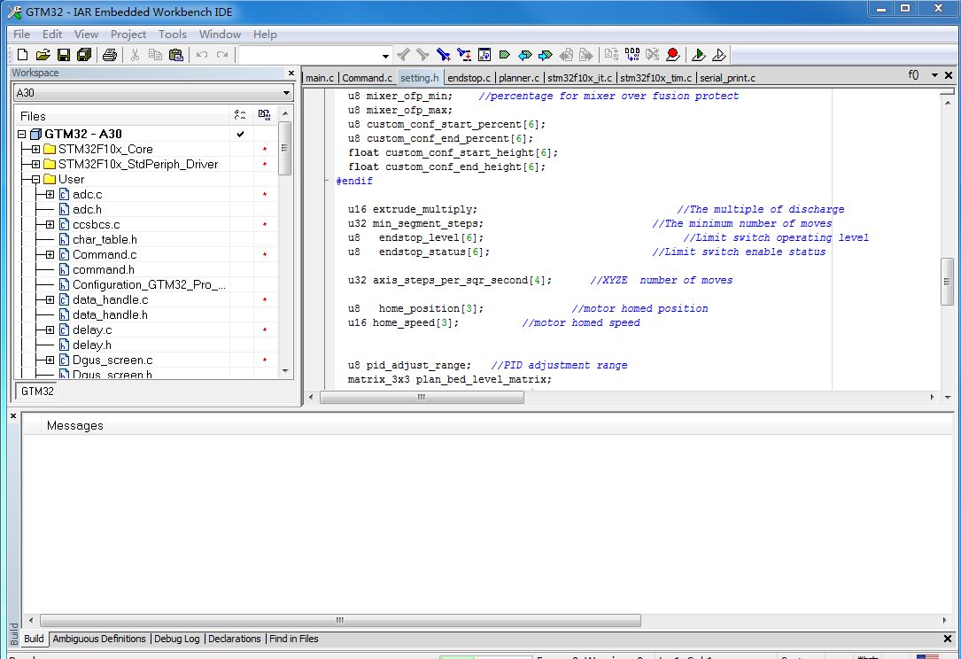

1. Select machine type ----A30

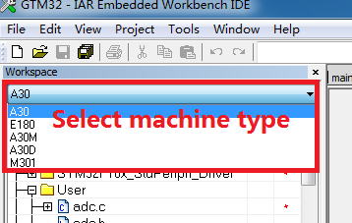

1. Modify the printer parameters in ‘Configuration_GTM32_MINI_A30.h’, for example: Extrusion head maximum temperature, Stepper motor steps per millimeter, Each axis acceleration….

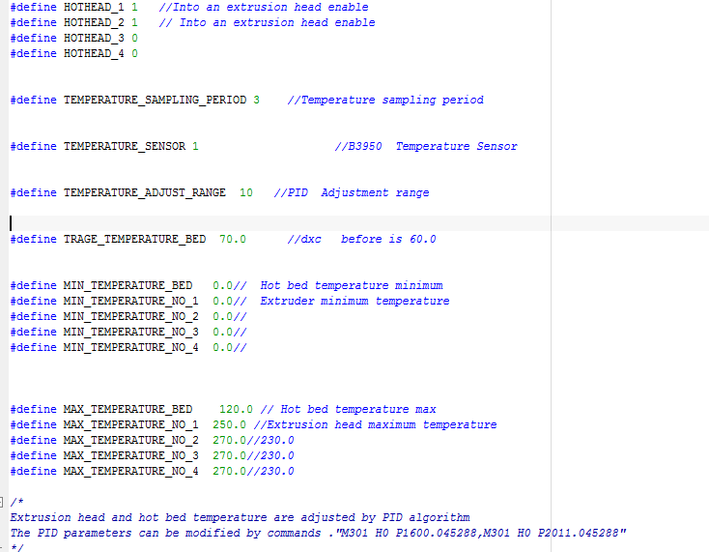

1. Compilation project

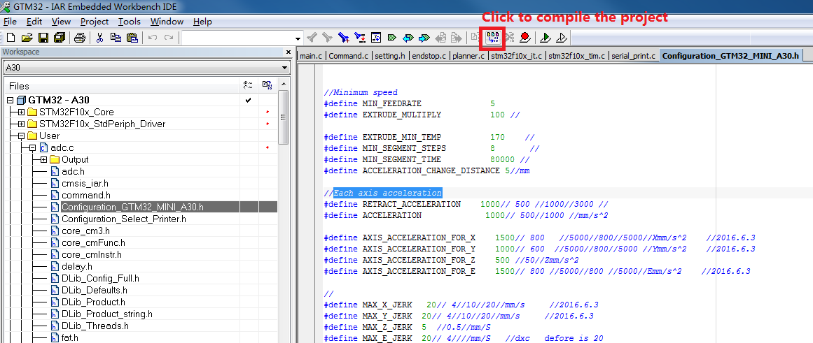

7、Compilation result ---- error 0

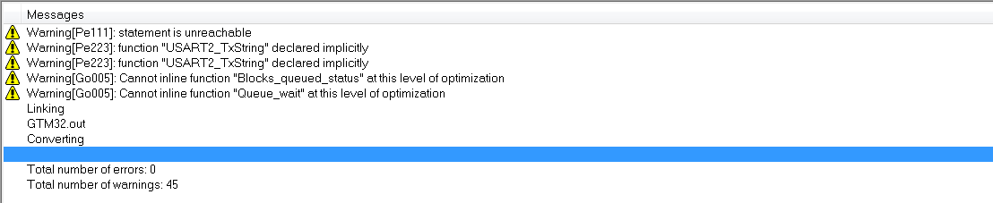

8、The generated target file directory is ’../IAR/project/A30/exe’

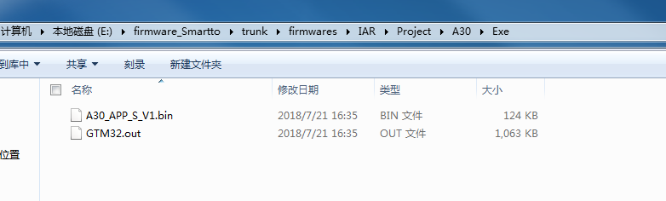

9、Download the firmware upgrade tool：<https://github.com/Geeetech3D/Smartto-IAR/blob/master/tools/smartto_firmware_tool_1_0_forWin.zip>

10、Double click on ‘main.exe’ to open 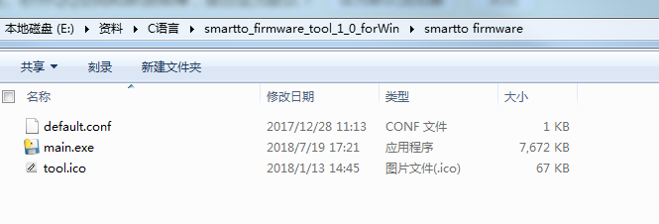

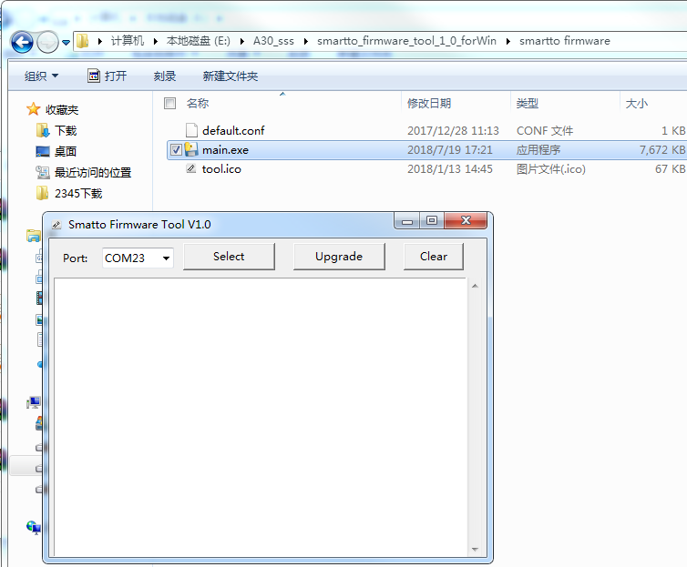

11、Click the ‘select’ button to select the upgrade file.

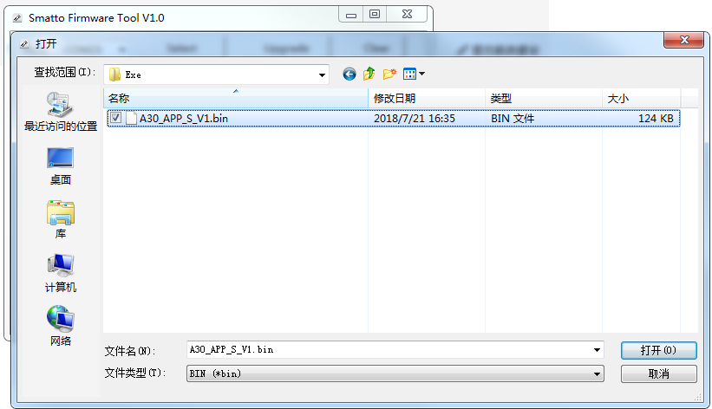

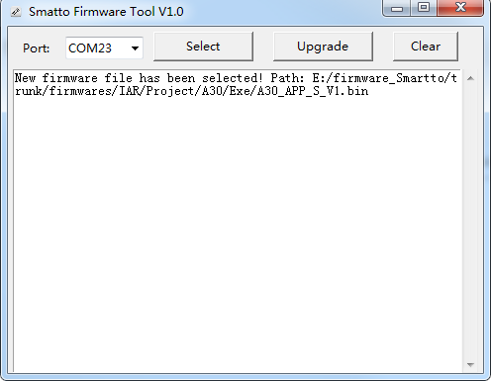

12、Click the ‘Upgrade’ button to start the firmware upgrade

